Recommendation System
What is a Recommendation System?
A recommendation system is a machine learning system that suggests items to users based on their preferences, behavior, or similarity to other users/items.
Examples
- Netflix → movies
- Amazon → products
- Spotify → songs
- YouTube → videos

Why Recommendation Systems are Important
- Reduce information overload
- Increase user engagement
- Improve personalization
- Drive business value (clicks, sales, retention)

Core Idea (Simple)
“If you liked this, you might also like that.”
The system learns patterns from:
- User behavior (clicks, views, ratings)
- Item attributes (category, genre, price)
- Other users’ behavior

Types of Recommendation System




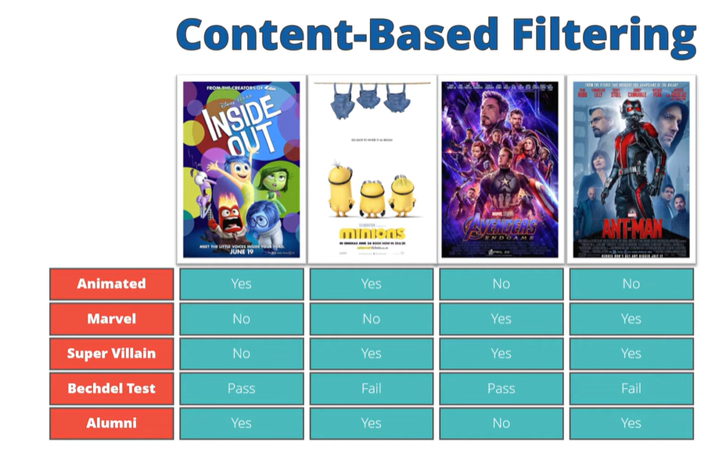
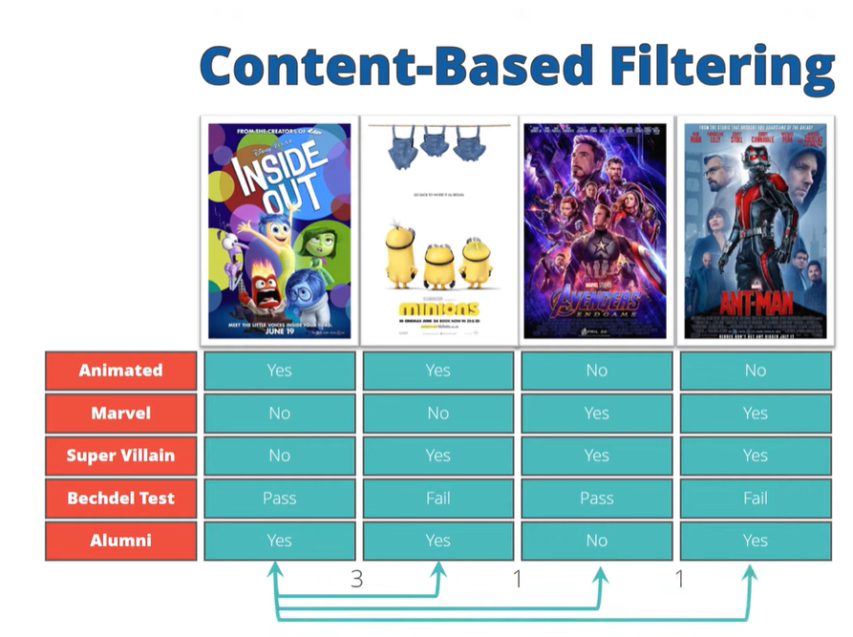

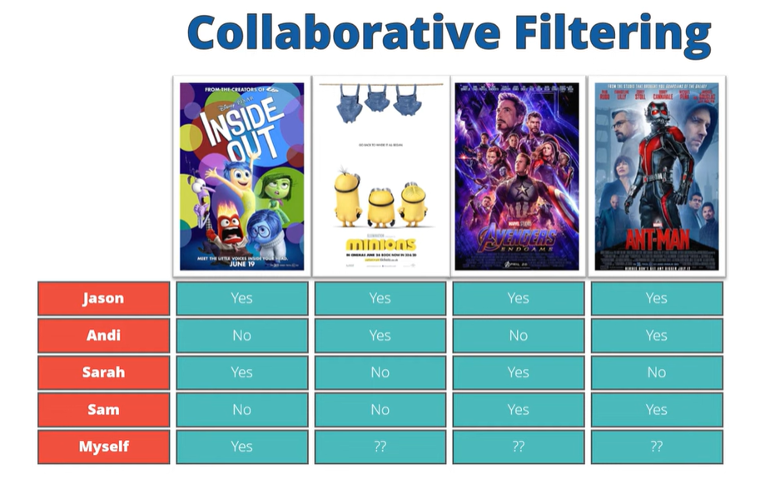
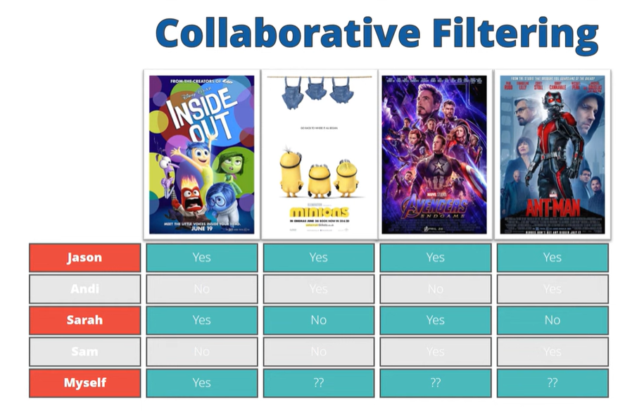

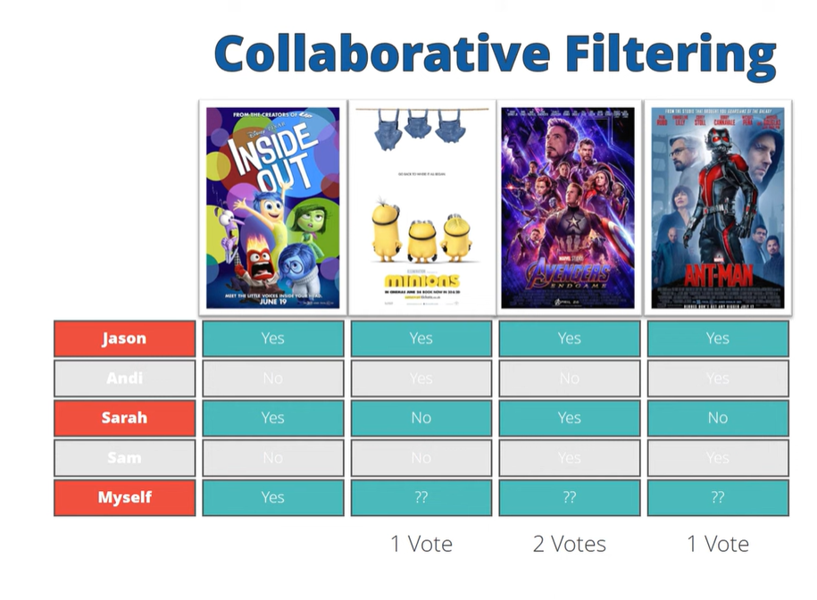



Quiz Questions

1. What is the primary goal of a recommendation system?
A. Increase database size
B. Predict user preferences and suggest relevant items
C. Reduce storage requirements
D. Improve network security

2. Which of the following is an example of a content-based recommendation?
A. “Users similar to you liked this item”
B. “Trending items this week”
C. “Because you watched action movies, here are more action movies”
D. “Most popular items overall”

3. Which technique relies on similarities between users or items?
A. Content-based filtering
B. Collaborative filtering
C. Rule-based systems
D. Random recommendation

4. What is the cold start problem in recommendation systems?
A. System crash during winter
B. Lack of data for new users or items
C. Slow system response
D. Overfitting of models

6. What are long-tail items?
A. Items with very high popularity
B. Items that are no longer available
C. Rarely interacted items with low popularity
D. Items with high ratings only

10. Which type of recommendation system combines multiple approaches?
A. Content-based
B. Collaborative
C. Rule-based
D. Hybrid

